TECHNICAL PROJECT REPORT

# Title of Invention / Project:

Smart Plant Watering system

# Team Members / Inventors:

|  |  |  |  |  |  |
| --- | --- | --- | --- | --- | --- |
| **S. No.** | **Name** | **Department** | **Designation** | **Mobile** | **E-Mail** |
| 1. | Abhinay Bhadani | ECE | Student | 7033376180 | abhinaybhadani99@gmail.com |
| 2. | Utsav Arora | ECE | Student | 8727076962 | ansh14113g@gmail.com |
| 3. | Soumyadeep Sinha Roy | ECE | Student | 6290300466 | deepsoumya73@gmail.com |
| 4. | Satyarth Raghuvanshi | ECE | Student | 7800402316 | srk.satyarth.1@gmail.com |
| 5. | Khushal Thakur | ECE | Mentor | 9646030764 | khushal.thakur@cumail.in |
| 6. | Anshul Sharma | ECE | Mentor | 9478697475 | anshulsharma.ece@cumail.in |
| 7. | Kiran Jot Singh | ECE | Mentor | 9463909689 | kiranjotsingh.ece@cumal.in |
| 8. | Divneet Singh Kapoor | ECE | Mentor | 9878422653 | divneet.ece@cumail.in |

Section – 1 (IPR Related)

# Brief Abstract:

This is an ongoing research study work. The objective of this study is to build an intelligent plant watering system for rural farmers. The study considered the availability of water supply in specific regions for five years. Also vital parameters statistics necessary for proper growth of each plant are stored in the system data base over the same period. Our study is primarily being guided by observations made in the rain fall pattern, different weather conditions, and environmental situation across the regions in the Northern and Southern parts of Nigeria. The target farmers are very poor. Therefore, our task is to produce a system that is affordable and reliable to these farmers. The complexity and stability of the system notwithstanding, overall, this study " Intelligent Plant Watering System for Rural Farmers " is being carried out to provide the rural farmers with a cheap, durable, power efficient, affordable, reliable, flexible, efficient and high performance intelligent plant watering system. Although this study is divided into three major groups, however, in this paper we try to present a subgroup that deals with soil moisture and fertility. The system based on its available statistics sets the various limits for the soil moisture, temperature and fertility. These features in the system ensure that water for irrigation is effectively managed and allowed to flow during specified temperature range. Also the soil fertility is properly regulated. This paper discursion focuses on the soil moisture and temperature.

# Existing state-of-the-art and Drawbacks in existing state-of-the-art

|  |  |  |
| --- | --- | --- |
| **S. No.** | **Existing state of art** | **Drawbacks in existing state of art** |
| 1 | https://electronicsforu.com/electronics-projects/hardware-diy/automatic-plant-watering-system | Most Power consumer, it is not Water resistance. Expensive |

# Additional modifications that you can propose to improve upon drawbacks

* However, that person used most kind of products to operate the circuit.
* Secondly, the circuit is most expensive and we made it simple and cheap.
* This makes it affordable for rural area people.

# Advantages

* No man power is needed, Better Output in low cost , Best for illierate people, easy to use.

Section – 2 (Real Project)

# Materials

|  |  |  |
| --- | --- | --- |
| Components | Quantity | Cost |
| Arduino Nano | 1 | 350 |
| Resistance 220 ohm | 1 | 2 |
| Switch | 1 | 10 |
| Soil Moisture Sensor | 1 | 110 |
| 220V Water Pump | 1 | 150 |
| Relay board 5V | 1 | 200 |
| Led’s | 2 | 2 |
| Resistance 1k | 1 | 5 |
| Resistance 10k | 1 | 8 |
| Capacitor | 1 | 10 |
| Transformer | 1 | 100 |
| Voltage Regulator | 1 | 80 |
| Diode | 3 | 5 |
| Wires | 10 | 35 |
|  | TOTAL | 1067 |

# Circuit Diagram

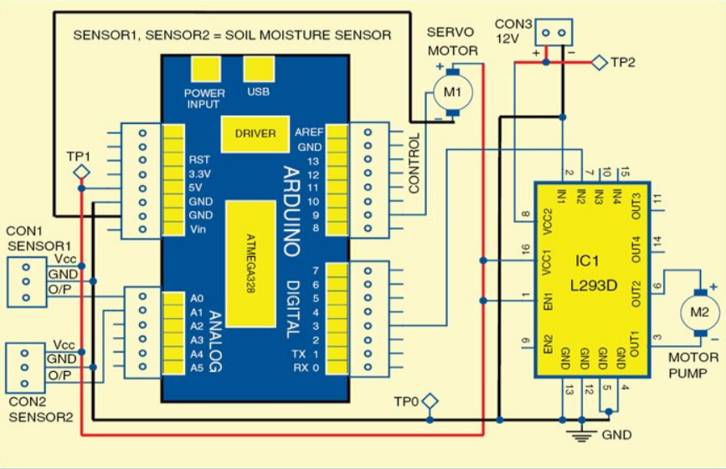

# Steps of Circuit Completion

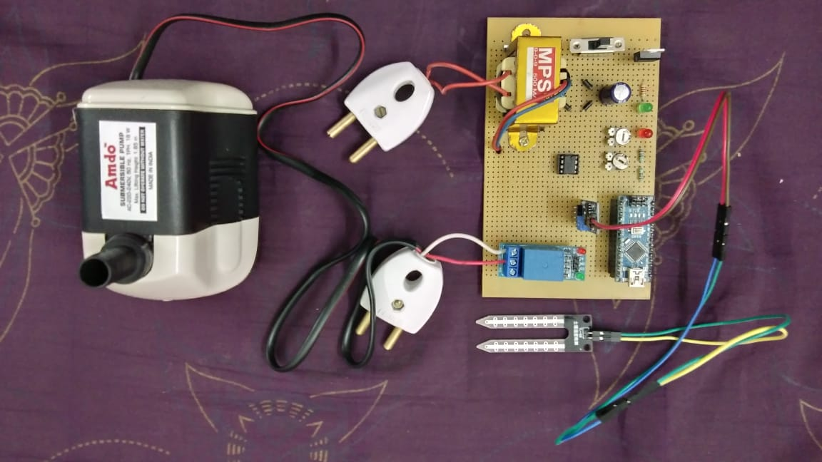

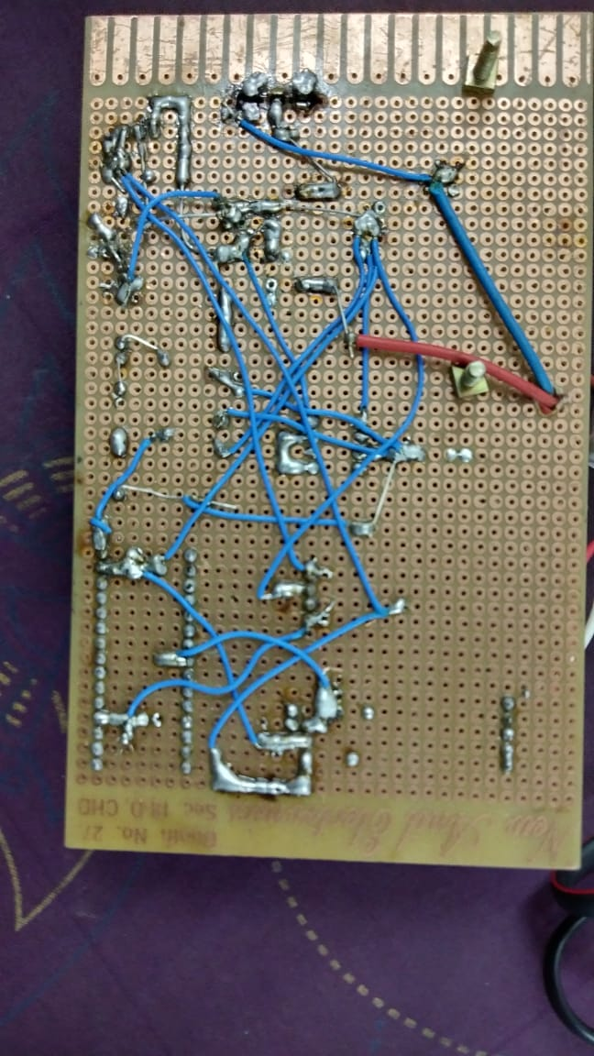

# Program Code

https://github.com/abhinaybhad45/SMART-PLANT-WATERING-SYSTEM.git